**KATHMANDU UNIVERSITY**

SCHOOL OF ENGINEERING

DEPARTMENT OF COMPUTER SCIENCE AND ENGINEERING

**PROJECT REPORT**



**EXPLORE NEPAL**

A first year project report submitted in partial fulfilment

of the requirements for ENGG 103

by:

Shakar Bhattrai (12)

Pratik Joshi (26)

Shradha Silwal (56)

Sudeep Mishra (64)

Andresh Singh (65)

**CERTIFICATION**

FIRST YEAR PROJECT REPORT

on

EXPLORE NEPAL

(a quiz to explore Nepal)

by:

Shakar Bhattrai (12)

Pratik Joshi (26)

Shradha Silwal (56)

Sudeep Mishra (64)

Andresh Singh (65)

Approved by:

1. Project Supervisor

______________ _________________________ __________

(Signature) (Name) (Date)

2. Head/In-Charge of the Department

_________________ ________________________ __________

(Signature) (Name) (Date)

**ACKNOWLEDGEMENT**

We wish to express our sincere thanks to the Department Of Computer Science And Engineering for including the ENGG 102 project into our curriculum.

We would also like to express our deep sense of gratitude to **Mr. Dhiraj Shresutha** for assigning to us this project .We sincerely appreciate his magnanimity by taking us into his fold for which we shall remain indebted to him. We would also like to express our heartily gratitude to our project supervisor **Mr. Bal Krishna Bal** for his regular guidance and encouragement throughout the project.

Taking this opportunity, we would like to thank all those individuals who directly or indirectly helped in making this project a successful one be it by encouraging us throughout the project or else through their valuable suggestions which we have tried out best to assimilate within our work.

**ABSTRACT**

Nepal being an underdeveloped country has not been able meet up to the level in the field of education sector due to poor educational infrastructure. Many children across Nepal ,in fact even some adults, don’t have basic general knowledges about various important places, its unique features and ethnic aspects and only recently have the technologies been introduced in many schools and educational sectors.

Hence, keeping these things into account,we hope that if given opportunity, our project would help to provide general knowledge about our nation through an entertaining way and also help to develop the intellectual power of the children. We also would be introducing some entertaining checkpoints after a certain interval of our work in order to enhance the entertainment provided through the game. Furthermore, mathematical quizzes, science and geography questions ,and cultural and sociological aspects too have been covered making it a multidimensional quiz rather than a traditional monotonous one.

Our society can be benefited if the project turns out to be a successful one. This report describes the overall design, planning, objectives and features of the game to be undertaken by us if given us an opportunity.

**TABLE OF CONTENTS**

Abstract ................................................................................................. i

Acknowledgement................................................................................ ii

**Chapter 1: Introduction**

1.1 Background .................................................................................... 1

1.2 Problem Statement.......................................................................... 1

1.3 Motivation....................................................................................... 2

1.4 Methdology..................................................................................... 3

1.5 Objective …................................................................................... .4

1.6 Case Study........................................................................................5

**Chapter 2: Discussion and System Overview**

2.1 Flow of game.................................................................................. 7

2.3 Algorithm Design............................................................................ 9

2.4 Tools Used...................................................................................... 11

**Chapter 3: Conclusion**...................................................................... 14

References.......................................................................................... 15

Bibliography....................................................................................... 15

Appendix............................................................................................ 16

**TABLE OF ILLUSTRATIONS**

|  |  |  |
| --- | --- | --- |
| S.N | Topic | Page No.: |
| 1 | Algorithm for Main menu module | 9 |
| 2 | Algorithm for Game play module | 9 |
| 3 | Algorithm for File Handling Module | 10 |
| 4 | Screenshot of Main menu module | 12 |
| 5 | Screenshot of Game play module | 12 |
| 6 | Screenshot of Mid WesternDevelopment Region Checkpoint | 13 |
| 7 | Screenshot of Far Western Development Region module | 13 |

**CHAPTER 1**

**INTRODUCTION**

1.1 BACKGROUND

Gifted with immense natural beauties,our country Nepal still has a long way to go in the field of technology. This is basically due to relatively uneducated population. On the other hand coping up with the day to day increasing advanced technologies has also been a challenge for our country. Hence, EXPLORE NEPAL, a multidimensional quiz helps to enhance the intellectual power of children while improving their general knowledges

1.2 PROBLEM STATEMENT

With computers and other electronics being introduced in many schools,educational sectors and Nepalese society still some technical knowledge and even the basic knowledge has been lagging among the Nepalese children. Though television has been providing few knowledge, there is lack of enough softwares to provide the children with easy and entertaining access such knowledge. Many leading schools and even the Nepalese society are in desperate need of such software and also we feel that there is a market for such softwares in present context.

Hence, EXPLORE NEPAL, a multidimensional quiz has been developed in order to solve the aforementioned problems.

1.2 MOTVATION

We’ve always wanted to develop something that would be useful for the society through our field. This project turned out to be bliss to our thoughts from the very first day.

The day of orientation of the First Year Project turned out to be a source of inspiration when Mr. Manoj Shakya, Mr. Dhiraj Shrestha and Mr. Prabin Gautam, oriented us on the topic of creating something genuine and fruitful out of the work rather than completing it for the sake of completing.

The teachers also briefed to us the organizations such as HELP Nepal which were working on providing the rural students of Nepal access to the educational programs and that there were lack of such programs for the project.

A brief time for discussion, and a quick formation of group members with similar plans led us to deliver, EXPLORE NEPAL, a multi-dimensional quiz game which we believe given a chance can do something, if not miracles, in order to help the rural students.

1.3 METHODOLOGY

The game is a dynamic, quiz based edutainment program that enables the user to learn and play simultaneously.

The user, most of who are speculated to be children of age groups 6 to 10, shall be allowed to input their name in a box at the beginning of the game.

Related questions from the general aptitude will be asked 5 per development region.

This game is analogous to the virtual tour of Nepal starting from the east to the west. The user enhances his position in the game by answering questions correctly. S/He shall be awarded 1 point for every correctly answered question.

* The whole Nepal is divided into 5 parts (Development Regions).
* The user will start his game from the Eastern Development Region.
* After answering 5 questions in each region, a checkpoint of the respective Development Region is displayed giving information about the Region.
* These checkpoints are intended to give education as well as entertainment.
* The user shall lose if the user is unable to answer more than 1 question.

Upon ending the game, the users name and score will be updating to an external text file.

1.4 OBJECTIVES

The main objectives of this project are:

1. To provide edutainment to the children of age group 6 to 10 about some general knowledge of the Nation.
2. To develop technical knowledge in the traditional Nepalese society.
3. To use the concept of python and pygame.
4. To cope up with the increasing technological development taking place across the globe
5. To get the idea about how to manage a project.
6. To promote nationalism.

1.5 CASE STUDY

This system was introduced after some brain storming of how to make a quiz interesting , informative and fun as well. We researched and collected some other quiz games.

Some existing quiz games are tabulated below:

**S. N. Name Defects/ Cons**

1. Kaun Banega Crorepati Inefficient GUI

2. Logo Quiz Less informative

3. Capital Quiz No gaming Breaks

Table 1: Defects of some of the existing quiz games.

Kaun Banega Crorepati(KBC),a flash-based quiz game named after the show, gained a great popularity in the past with its simple yet powerful interface. Table 2 depicts the differences between KBC and Explore Nepal.

Table 2:A comparison between the closely related game KBC and Explore Nepal

|  |  |
| --- | --- |
| **Kaun Banega Crorepati** | **Explore Nepal** |
| 1. Questions mostly based on Indian history  and geographical details | 1. Questions relevant to Nepal, and general aptitude questions |
| 2. No Randomization of options | 2**.** Randomization of Options |
| 3.Simlar Gameplay | 3. Dynamic Game play with varying backgrounds |
| 4. Non-Graphical(closely console)  answer selection | 4. Interactive answer selection via character's keyboard movement |
| 5. No options for registering scores | 5. Options for registering scores on an external file |
| 6. Continous Gameplay | 6. Gameplay with checkpoints after every five questions. |
| 7. Major Objective-QUIZ | 7. Major Objective- Explore Nepal , descriptive information about each Development Region. |
| 8. A single level game | 8. Game with five different levels |

**CHAPTER 2**

**DISCUSSION AND SYSTEM OVERVIEW**

2.1 FLOW OF GAME

In “EXPLORE NEPAL”, the game, the user is asked to input his name via a inputbox and then he/she is forwarded to the game.

The game starts off with a short tutorial on playing the game, which is made as enteratainable as possible.

The game play module then takes over, where a series of random questions with options in random positions are blit in the screen. The questions are carefully selected to match the age group(s) targeted. Each of the question has a correct option which is to be selected by the user via keyboard controls of a character at the center of the screen. Each game play module has randomly generated background images that reflect the Nepali society and culture.

The entire game is divided into five levels, each level corresponding to each of Nepal's development region. During the game play module, after every five questions, a checkpoint is displayed which acts as a bridge between one level to another. The checkpoint provides information on the concerned development region in an entertaining manner.

All the database(questions and options) required for the game play are maintained in an external file. A separate file handling module is used to handle these files.

The game completes if the user is able to answer all twenty five questions presented to him/her. Upon being incorrect for even a single time, the game comes to an end.

**2.2 FLOW DIAGRAM**

2.3 ALGORITHM DESIGN

2.3.1 GAME PLAY ALGORITHM

1. Start

2. Get a random question from file handling module

3. Get options from file handling module for the given question in random order

4. Get the user desired answer

5. If the answer, is correct display congratulating module

6. If the answer is incorrect, display You're Wrong Module and goto 8

7. If some questions are remaining goto 2

8. Stop

2.3.2 CHECKPOINT ALGORITHM

1. Start

2. If scores is a multiple of 5, display checkpoints for EDR,CDR,WDR,MWDR,FWDR respectively.

3. Stop

2.3.3 FILE HANDLING ALGORITHM

(Note: All the questions and options are maintained in an external file, in serial order)

2.3.3.1 FILE HANDLING FOR GETQUESTIONS

1. Start

2. Get the question number as argument

3. Loop through the lines

4. If the line matches the question number, return the particular line

5. Stop

2.3.3.2 FILE HANDLING FOR GETOPTIONS

1. Start

2. Get the question number as argument

3. Loop through the lines

4. If the line matches the question number, return the four lines after the particular line

5. Stop

2.3.3.2 FILE HANDLING FOR GETOPTIONS

1. Start

2. Get the score number as argument

3. Loop through the lines

4. If the line matches the question number, return the two lines after the particular line

5. Stop

2.4 TOOLS USED

For the development of our game "Explore Nepal", we have used Python language. All the development of the program has been done in Linux as well as Windows environment.

We have used the following tools and applications:

1. Idle2.7.6 (Integrated development environment for python).

2. Pygame (Python interface to SDL)

3. Python standard libraries.

4. Adobe Photoshop CS6

5. Inputbox Class

6. Online GIF Exploder

2.5 SCREENSHOTS

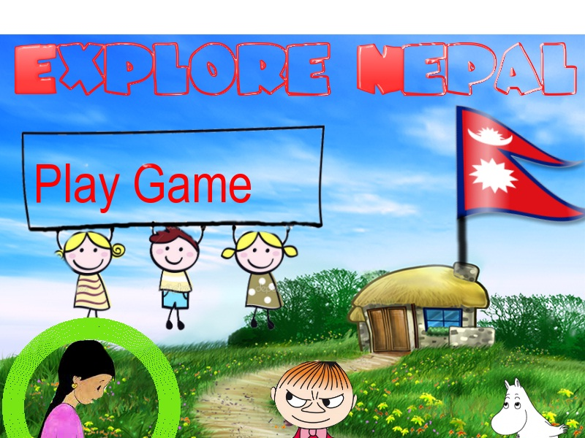

Fig 1: Screenshot of Main menu module

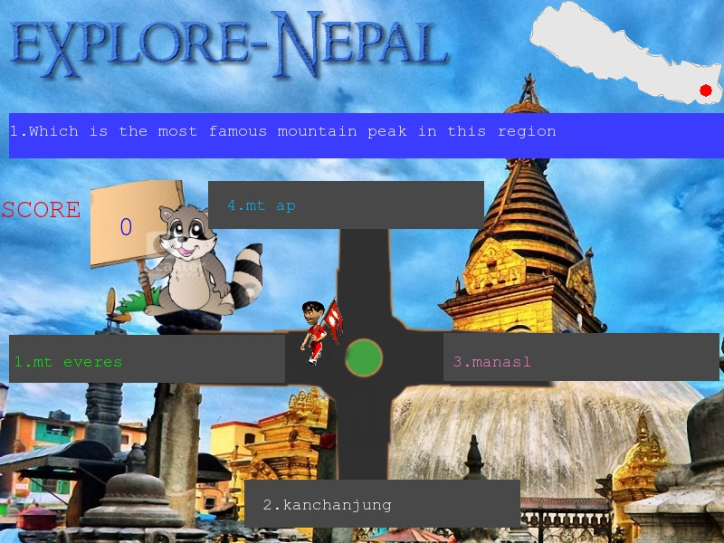

Fig 2: Gameplay

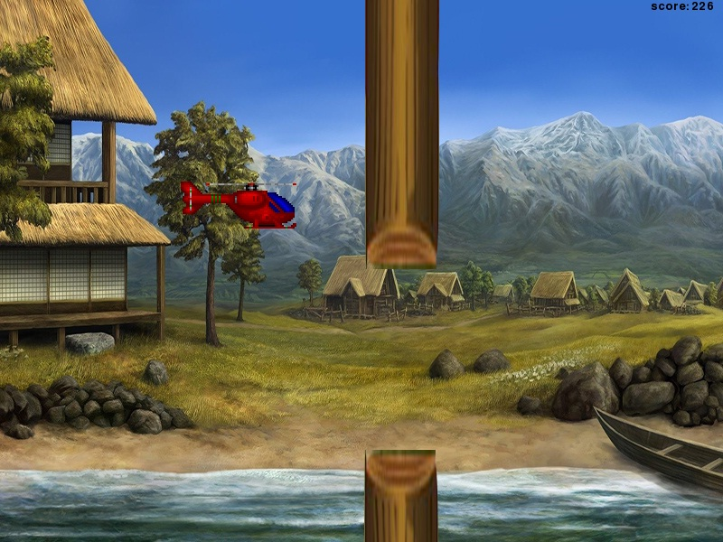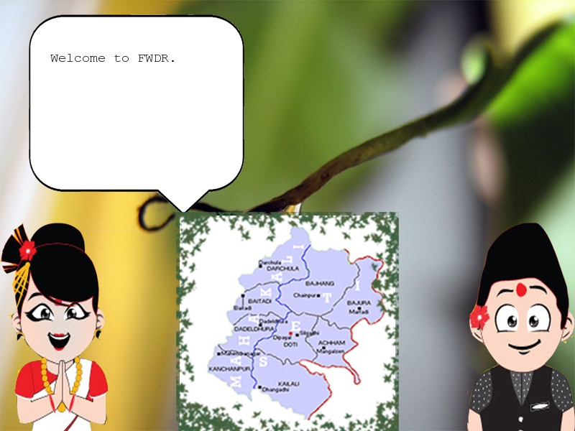

Fig 3: Screenshot of MWDR Checkpoint

Fig 3: Screenshot of FWDR Checkpoint

**CHAPTER 3:**

**CONCLUSION**

We have achieved the following results:

- Providing an interactive learning environment

- Database management in external file

- Completed GUI interface

- Completed the use of hover effect

- Installation of music in different modules

- Use of time based animations

- Linking different modules

This project has a lot of room for expansions like:

- Making it more interactive and entertaining

- Installing more gaming sections

- Including more checkpoints

We believe that most important lesson to be grasped through this project were to enhance our programming skills in languages other than the one included in the curriculum, to produce something useful for the society, and to enhance our ability to work on group understanding each other's ideas.

We are all satisfied with our results and would love to induge ourselves in such projects enthusiastically in the days to come.

REFRENCES/BIBLIOGRAPHY

1. “Python Programming for the Absolute Beginners”, by Michael Dawson
2. Game Development Tutorials for Pygame, from <https://www.youtube.com/results?search_query=game+developmenmt+tutorial+pygame>
3. “Learning Python”, by Mark Lutz.
4. About Python https://[www.learnpython.org](http://www.learnpython.org/)
5. About Pygame from https://[www.pygame.org](http://www.pygame.org/)
6. Debugging with the help of[https://www.stackoverflow.com](https://www.stackoverflow.com/)
7. Online GIF Exploder from <https://www.gifmaker.me/exploder/>

APPENDIX

Follwing is the Gantt-Chart showing, how the project was completed

|  |  |  |  |  |  |  |  |  |  |  |  |  |  |
| --- | --- | --- | --- | --- | --- | --- | --- | --- | --- | --- | --- | --- | --- |
| SN | Title | Week | | | | | | | | | | | |
| 1 | 2 | 3 | 4 | 5 | 6 | 7 | 8 | 9 | 10 | 11 | 12 |
| 1 | Research and Analysis |  |  |  |  |  |  |  |  |  |  |  |  |
| 2. | Coding and System Design |  |  |  |  |  |  |  |  |  |  |  |  |
| 3. | Debugging |  |  |  |  |  |  |  |  |  |  |  |  |
| 4. | Beta testing |  |  |  |  |  |  |  |  |  |  |  |  |
| 5. | Documentation |  |  |  |  |  |  |  |  |  |  |  |  |